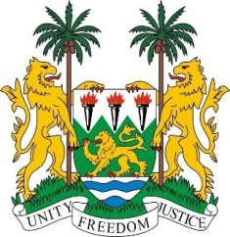
SIERRA LEONE
23rd Session of the UPR

MAURITANIA

3 November 2015

Mr President,

Sierra Leone warmly welcomes the delegation of Mauritania to this second UPR cycle and thanks them for their national report.

My delegation notes with appreciation the efforts undertaken by the Government of Mauritania since their last review cycle, most notably the constitutional review of 2012, the adoption of a road map and action plan to eradicate contemporary forms of slavery and its consequences, as well as the ongoing efforts to address child labour through the creation of a national action plan and the accession to various international human rights instruments including the ICPED and the CRPD, as well as two optional protocols.

In addition, we note Mauritania’s de facto moratorium on the death penalty since 2007, and encourage the government to consider its abolition.

Sierra Leone however remains concerned about reports of racial discrimination and would encourage Mauritania to enact laws on anti-discrimination, especially with regard to racial prejudice and disparities in citizenship rights for its nationals.

Recommendations:

- Submit its overdue reports to the special procedures mechanism, including CEDAW and the CRC.
- Enact laws which fully abolish child, early and forced marriage (CEFM).
- Modify its national law to define rape as a criminal offense.
- Undertake, with international assistance, human rights training for the judiciary.
- Include a human rights component in the school curriculum.

Sierra Leone wishes Mauritania every success.

Thank you, Mr President.

